Received 12/9/2016
Clerk-Treasurer’s Office
Auburn, IN 46706

ORDINANCE NO. 2016-21
AN ORDINANCE VACATING ALLEY RIGHT-OF-WAY
IN THE 200 BLOCK OF WEST SEVENTH STREET
IN THE CITY OF AUBURN, INDIANA

SUMMARY

This ordinance vacates a platted alley in the Western Addition to the City of Auburn in accordance with Indiana Code §36-7-13-12. The alley is located south of the West Seventh Street right-of-way and north of the West Eighth Street right-of-way; parallel to and between South Jackson Street and South Van Buren Street. The alley is 16½ feet wide by 132 feet long. It is located east of Lot 66 and Lot 65 and west of Lot 15 and Lot 16 all in the Western Addition to the City of Auburn, Indiana.
The City of Auburn shall retain a public utility easement over said real estate to maintain existing utility infrastructure in accordance with Indiana Code §36-7-3-16. A full copy of said ordinance is available for inspection at the office of the Clerk-Treasurer, City of Auburn or on the City of Auburn’s internet website at www.ci.auburn.in.us.

X | Recorder’s Office |  | X | Publish Public Hearing
 | Auditor’s Office |  | Tuesday, January 3, 2017
 | Clerk’s Office |  | X | Publish O/R after Adoption
 | Other
X | Building Department
X | Engineering Department
 | DeKalb County Plan Commission
X | Internet Code Site – Council Ordinances

ORDINANCE NO. 2016-21
AN ORDINANCE VACATING ALLEY RIGHT-OF-WAY
IN THE 200 BLOCK OF WEST SEVENTH STREET
IN THE CITY OF AUBURN, INDIANA

WHEREAS, a petition to vacate a certain public right-of-way has been submitted to the City of Auburn, Indiana by VRJ Holdings, Inc.; and

WHEREAS, the City of Auburn desires to vacate certain right-of-way more particularly located as follows:

The alley located south of the West Seventh Street right-of-way and north of the West Eighth Street right-of-way; parallel to and between South Jackson Street and South Van Buren Street. The alley is 16½ feet wide by 132 feet long. It is located east of Lot 65 and Lot 66 and west of Lot 15 and Lot 16 all in the Western Addition to the City of Auburn, Indiana.
WHEREAS, a Public Hearing of the City of Auburn Common Council was held on January 3, 2017 at 6:00 PM in the Auburn Common Council Chambers regarding the petition for vacation; and

WHEREAS, the City of Auburn has provided notice, pursuant to Indiana Code §36-7-3-12(c) and 5-3-1 et. seq. that it desires to vacate certain public rights-of-way; and

WHEREAS, a second reading of the Ordinance was held on January 3, 2017, and

WHEREAS, due consideration and opportunity has been given for public notice and comment.

IT IS NOW THEREFORE ORDAINED BY THE COMMON COUNCIL
OF THE CITY OF AUBURN, INDIANA THAT:

Section 1.
The alley right-of-way to be vacated is illustrated in Exhibit A, consisting of two (2) pages, which is attached hereto and made a part hereof further setting forth the area being vacated. The western two (2) feet of the vacated right-of-way shall be awarded to adjoining lots to the west (Lot 65 and Lot 66). The eastern fourteen and one-half (14½) feet of the vacated right-of-way shall be awarded to the adjoining to the east lots (Lot 15 and Lot 16).

Section 2.
The Municipal City of Auburn shall retain an easement across the vacated right-of-way for the purpose of maintaining existing utility infrastructure. The Municipal City of Auburn shall have the right to maintain and repair existing utilities within said vacated rights-of-way but shall not install any additional utilities.

BE IT FURTHER ORDAINED that this Ordinance shall be in full force and effect
from and after publication of the summary of this Ordinance in a newspaper of general
circulation in DeKalb County, Indiana. A full and complete copy of the Ordinance shall
be kept on the City of Auburn website under the Council information at
www.ci.auburn.in.us.

PASSED AND ADOPTED by the Common Council of the City of Auburn,
Indiana, this 3rd day of January, 2017.
________________________________
James Finchum, Councilmember

ATTEST:

_________________________
Patricia Miller, Clerk-Treasurer

Presented by me to the Mayor of the City of Auburn, Indiana, this 3rd day of
January, 2017.

______________________________
PATRICIA MILLER, Clerk-Treasurer

APPROVED AND SIGNED by me this 3rd day of January, 2017.

_____________________________
NORMAN E. YODER, Mayor

VOTING: AYE NAY

Kevin Webb

James Finchum

Dennis (Matthew) K. Kruse II

Wayne Madden

Michael Watson

Dennis Ketzenberger

Michael Walter
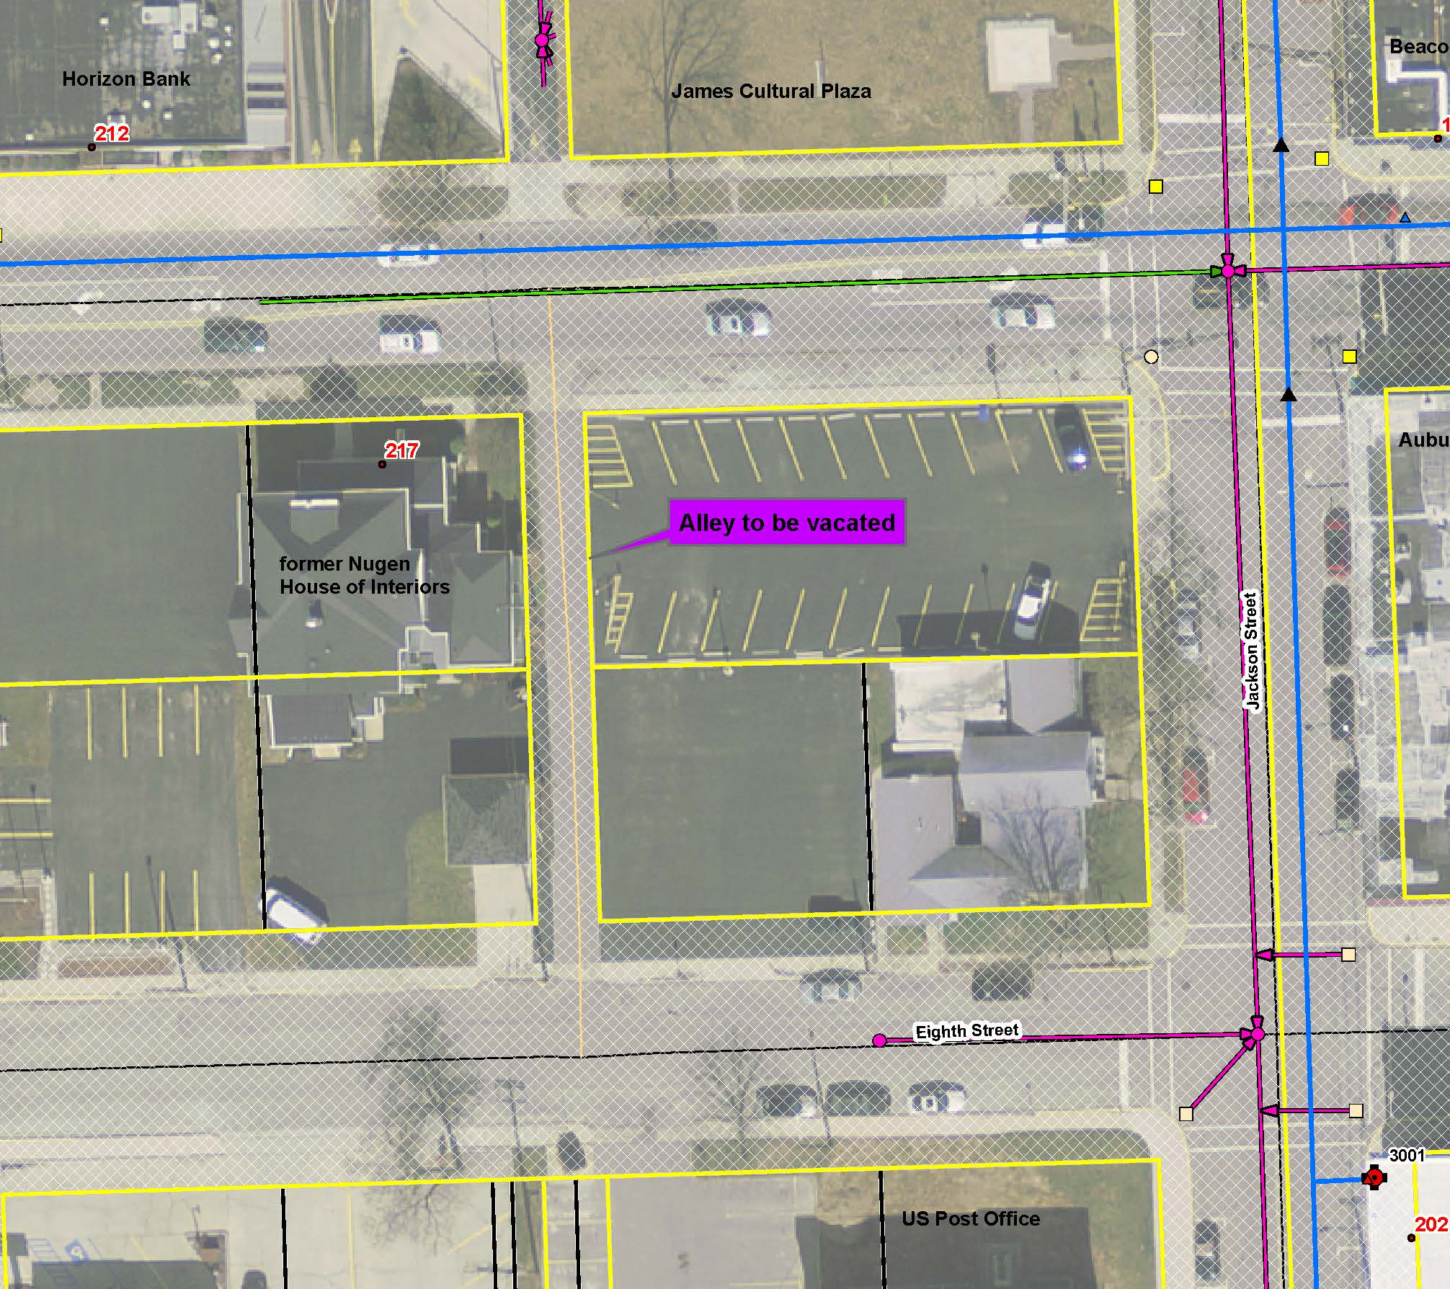
Exhibit A

